GREGORIO, JAHCY G
BSIT 3F2

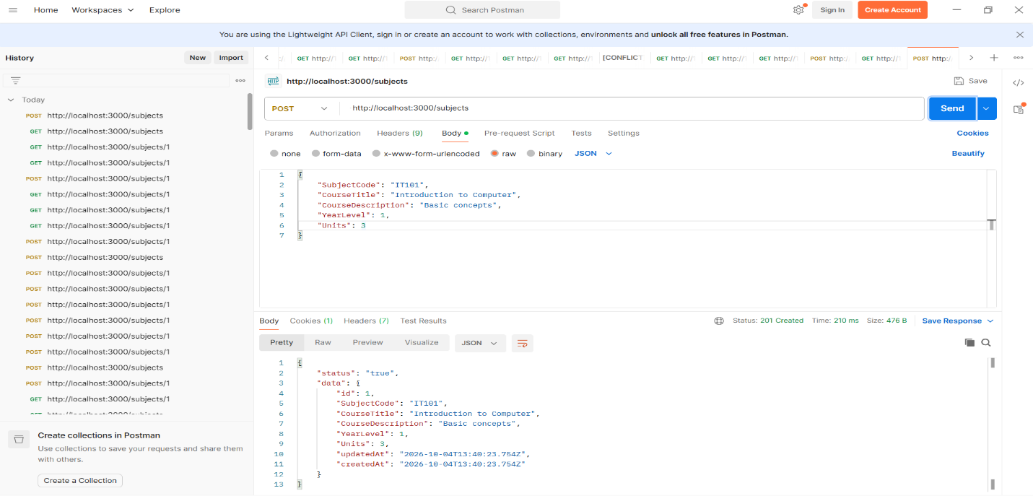
Subject (POST): http://localhost:3000/subjects

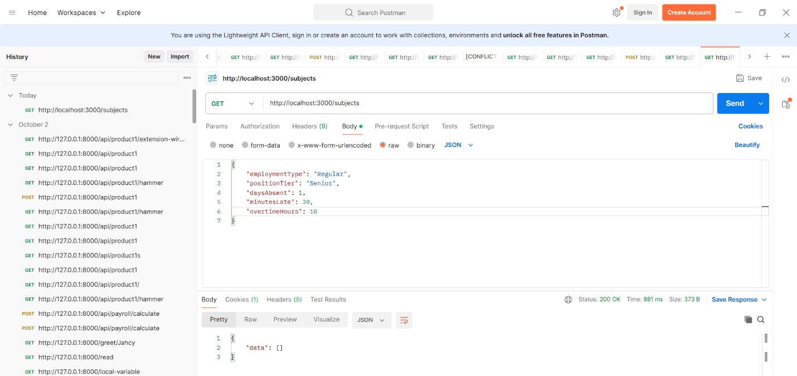
Subject (GET): http://localhost:3000/subjects

ID (Get): http://localhost:3000/subjects/1
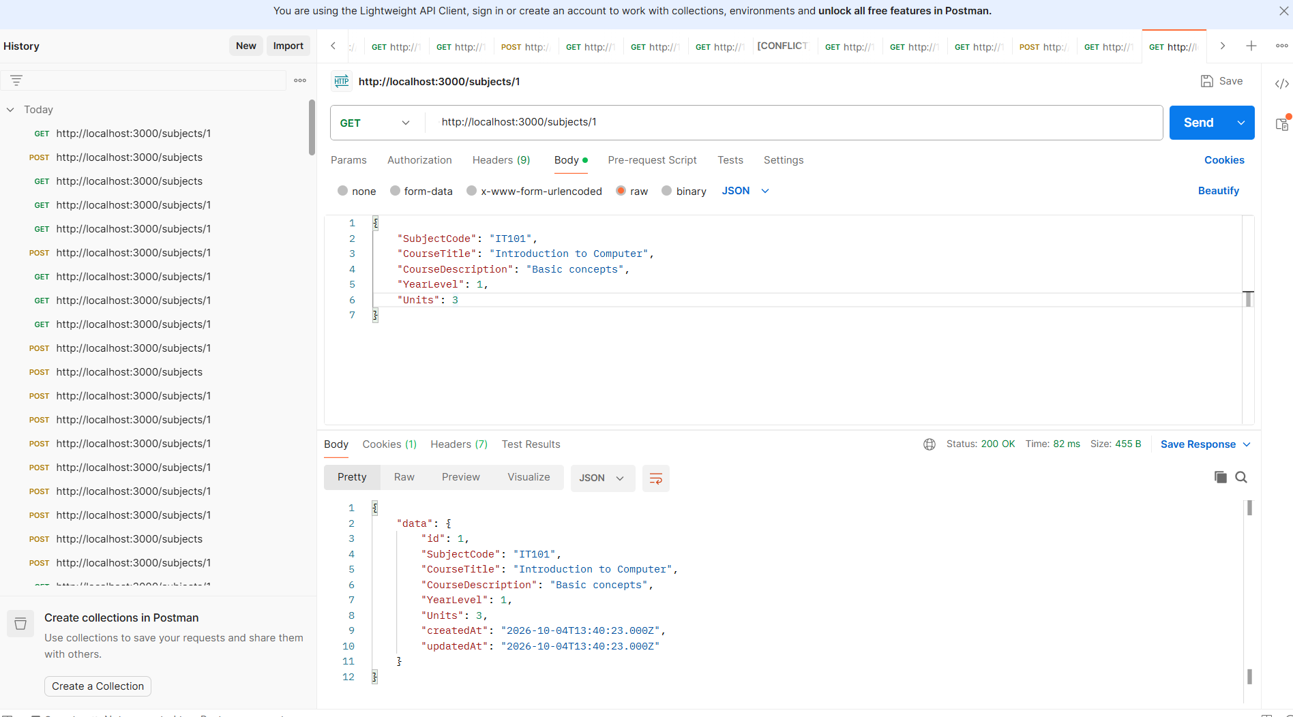

courses (POST): http://localhost:3000/courses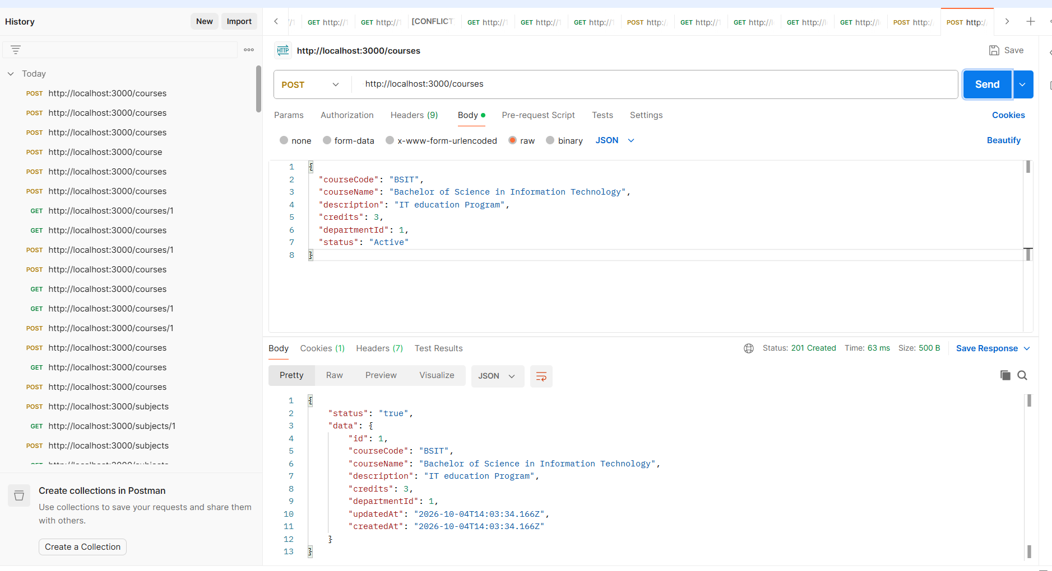

GET http://localhost:3000/courses
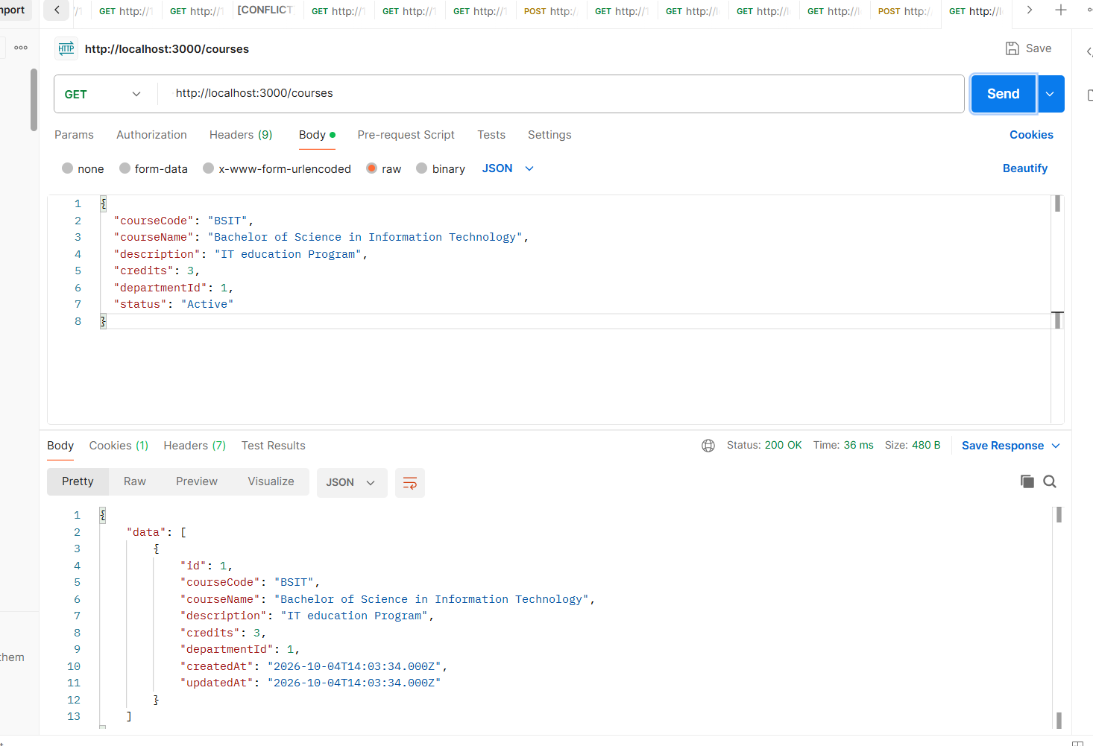
GET http://localhost:3000/courses/1

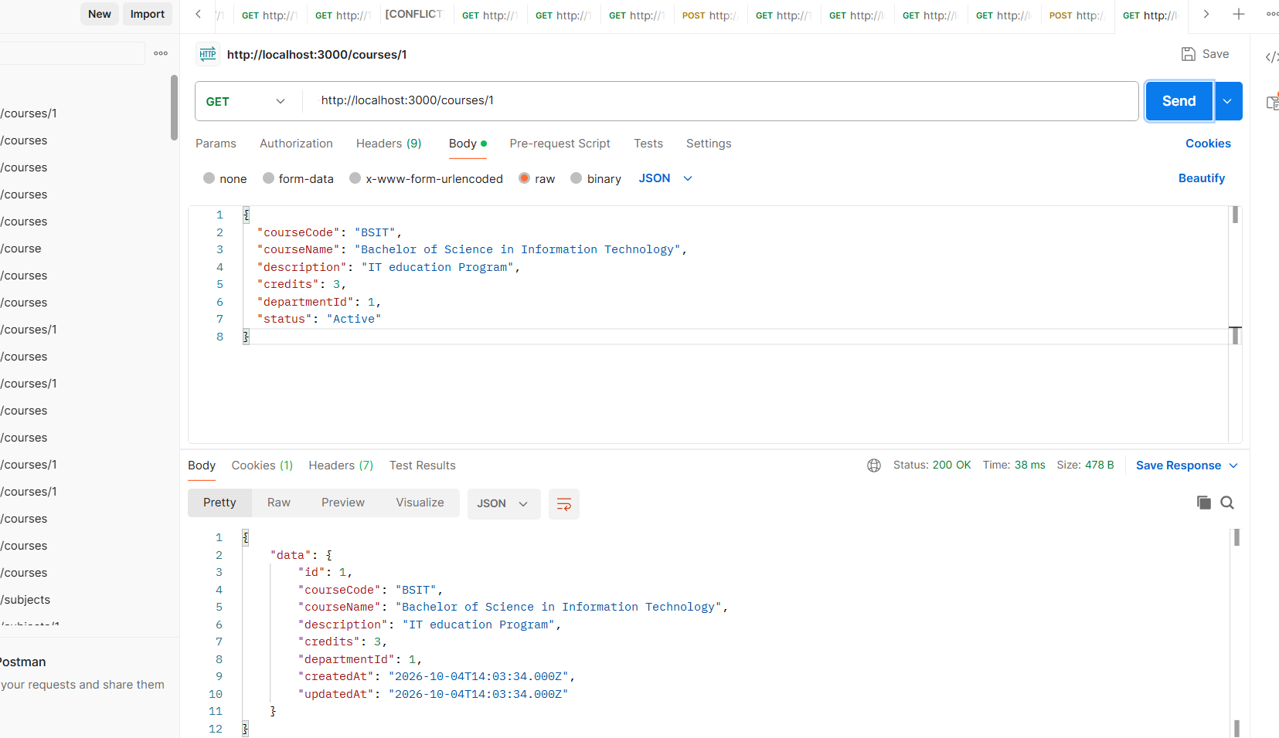

DEPARTMENTS
GET http://localhost:3000/departments
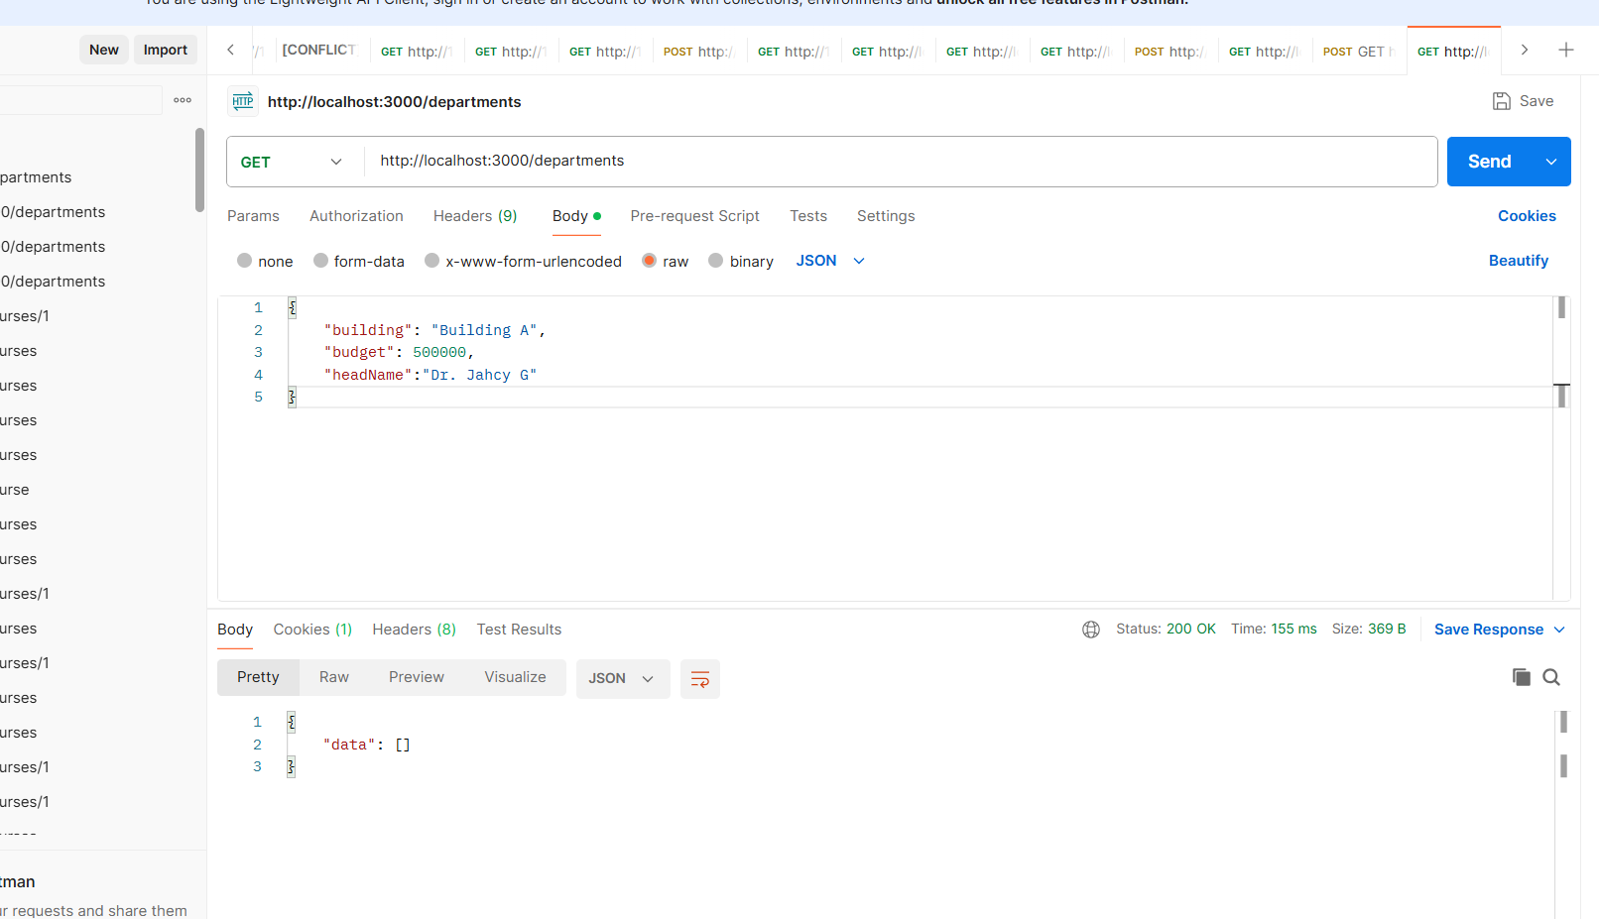
POST http://localhost:3000/departments

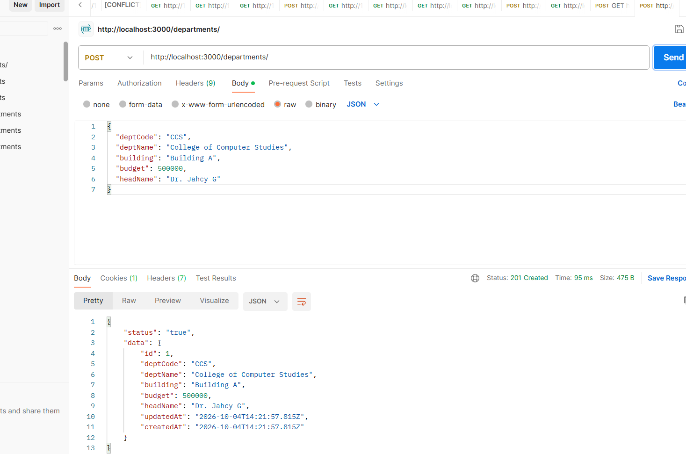

GET(ID) http://localhost:3000/departments/1
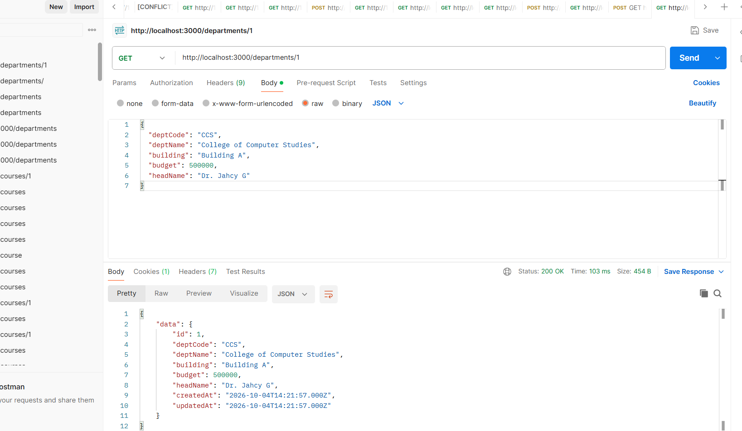
GET http://localhost:3000/enrollments
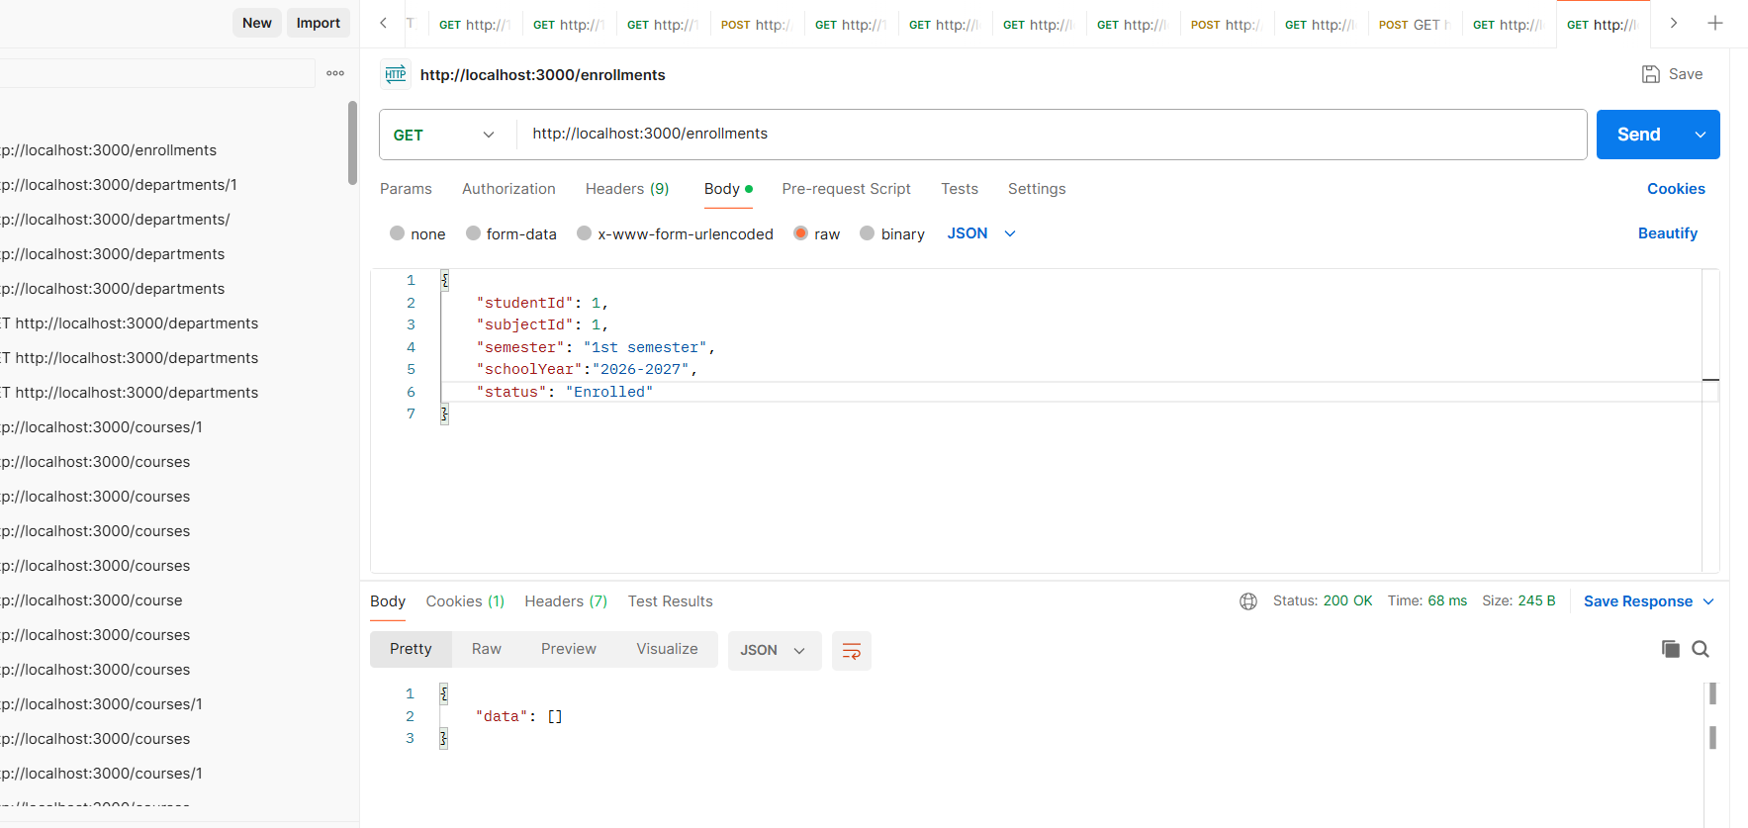

POST http://localhost:3000/enrollments
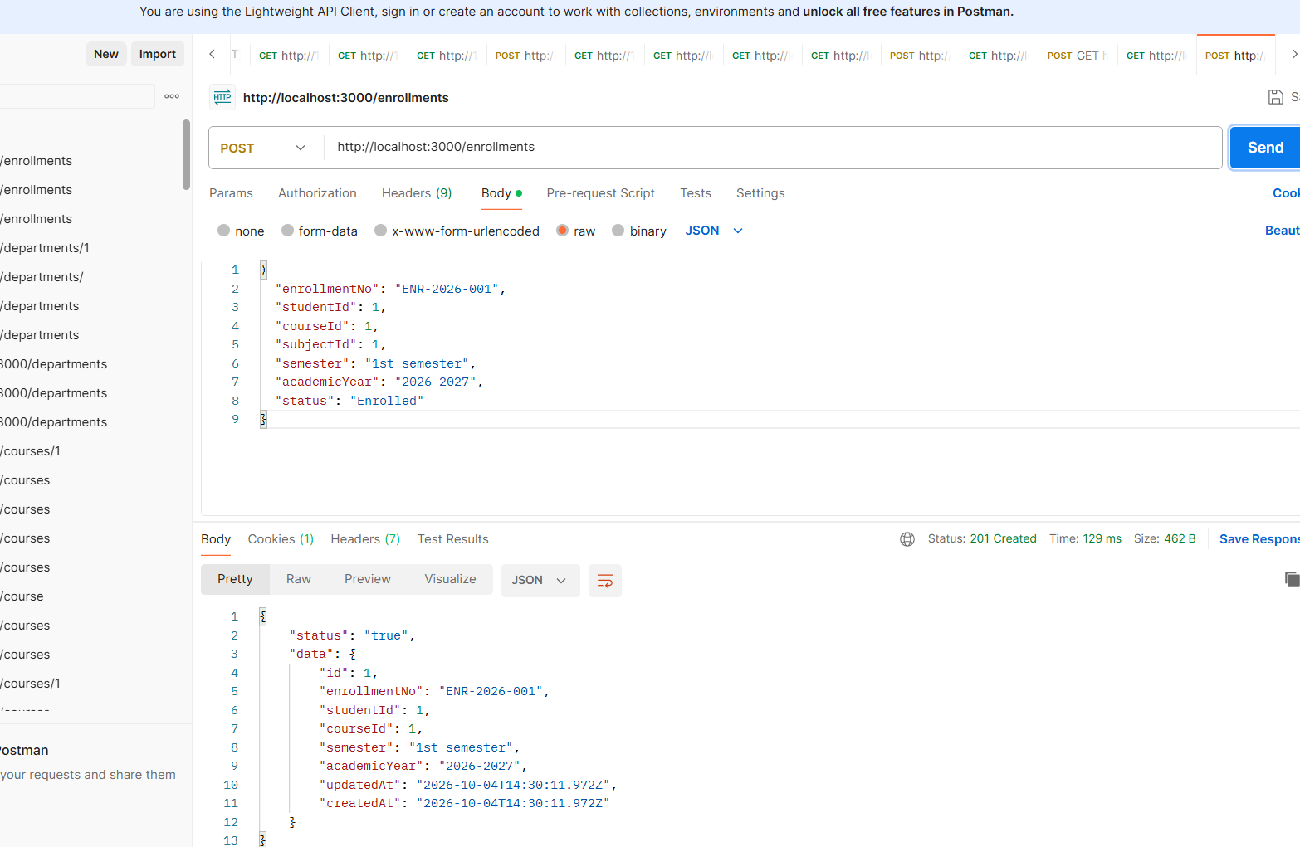
GET(ID) http://localhost:3000/enrollments/1
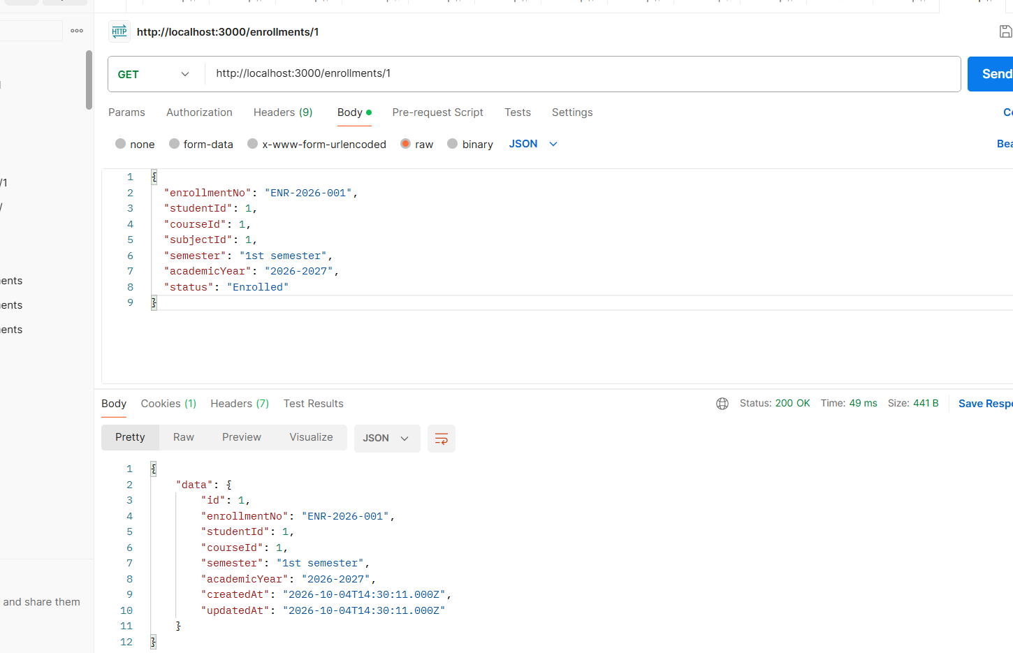

GET http://localhost:3000/instructions
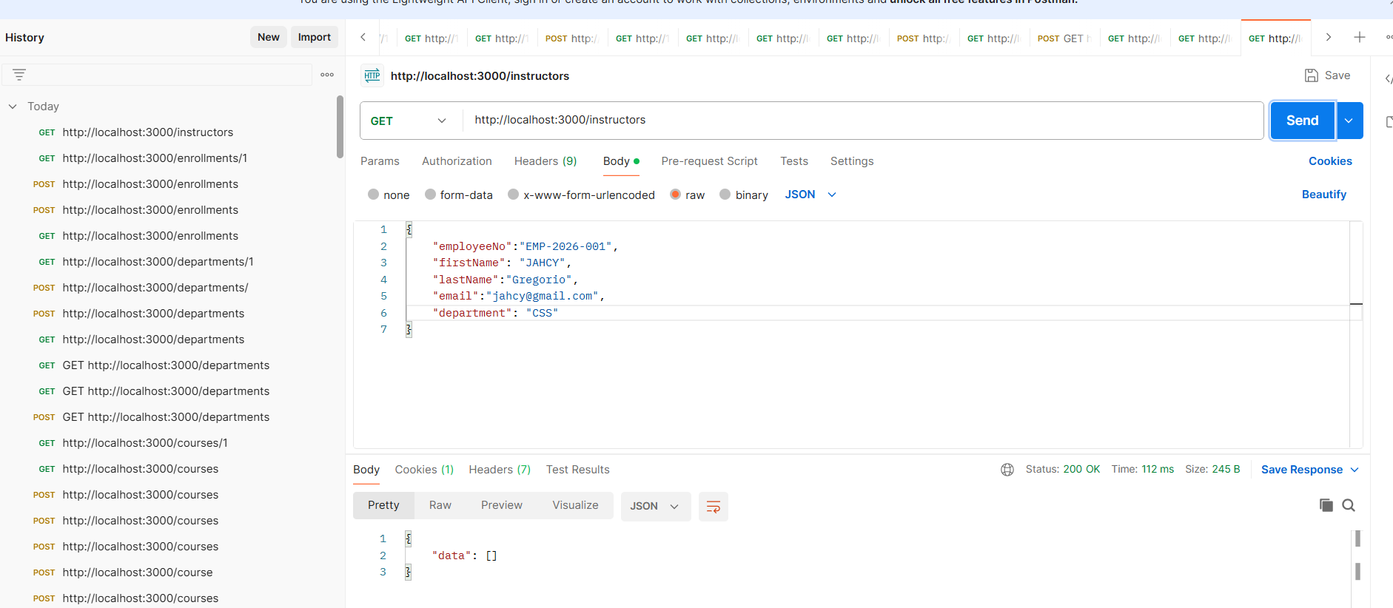
POST http://localhost:3000/instructions
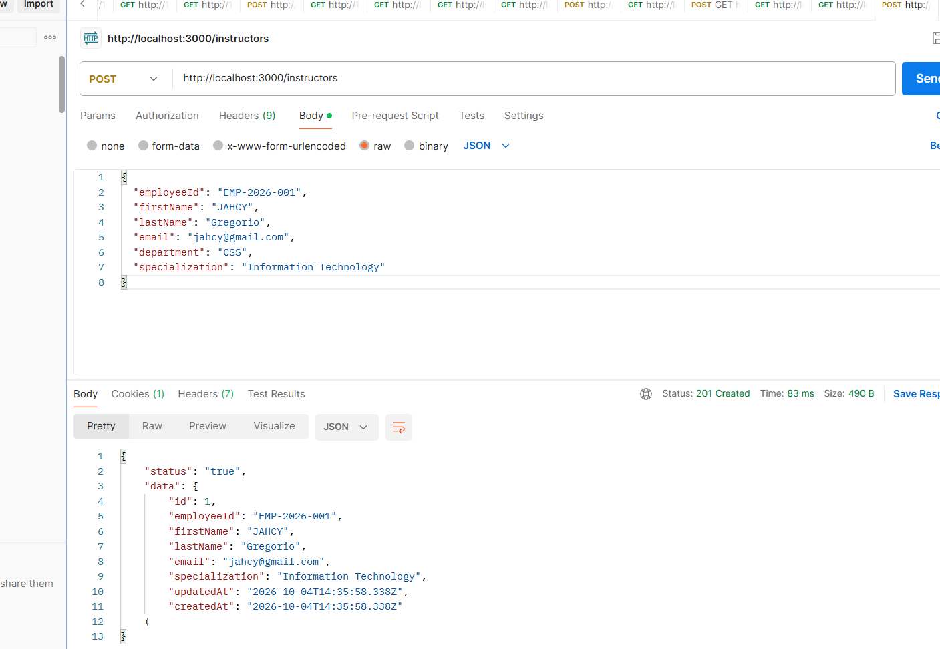

GET(ID) http://localhost:3000/instructions/1
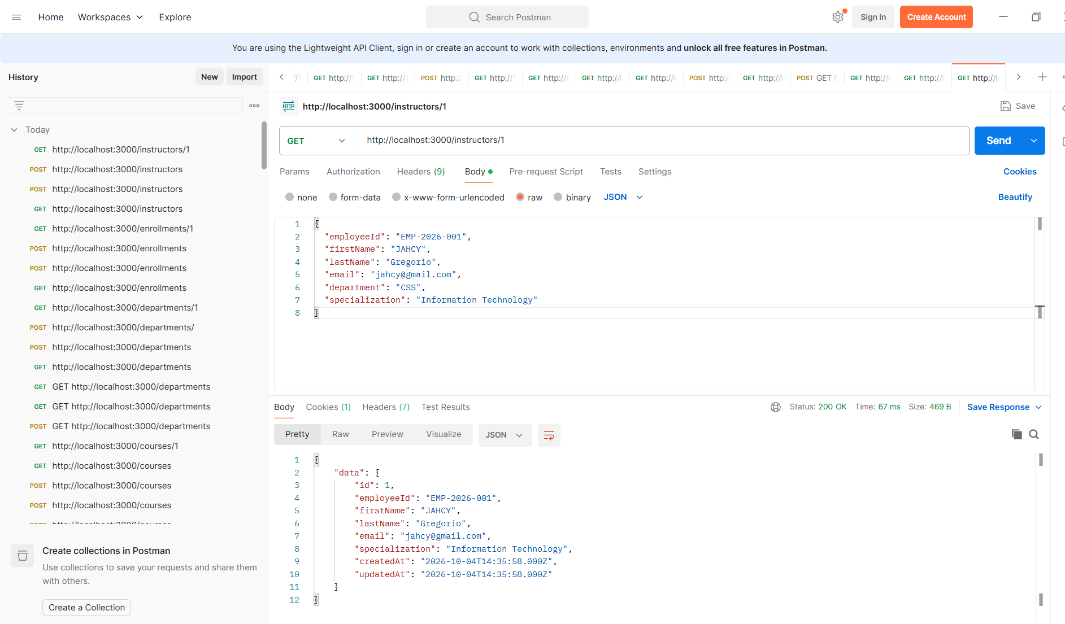
GET http://localhost:3000/students
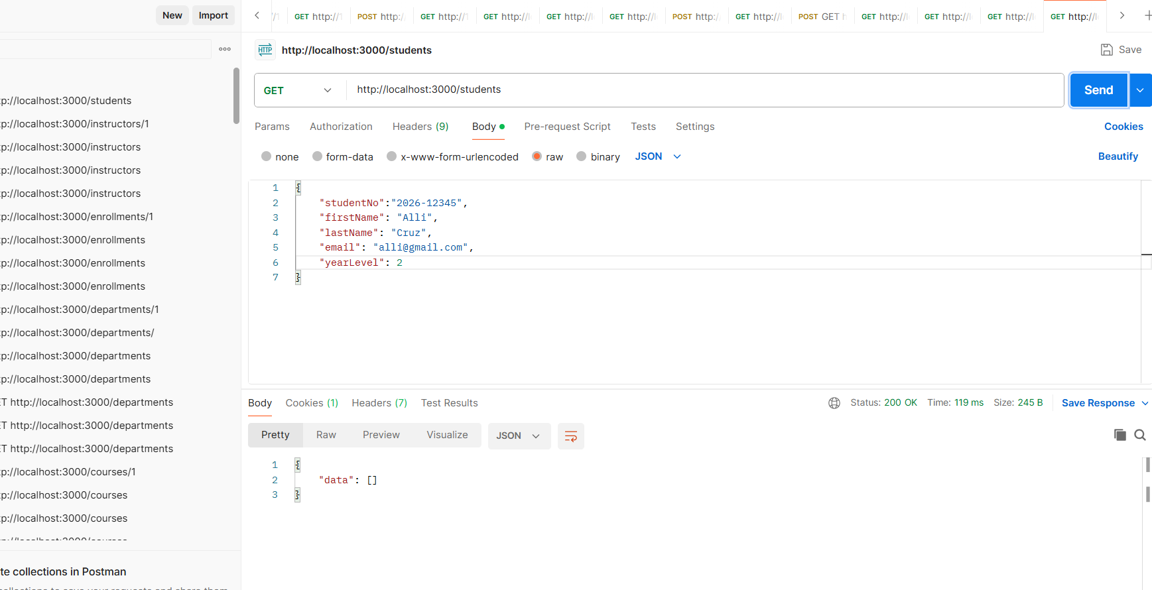

POST http://localhost:3000/students
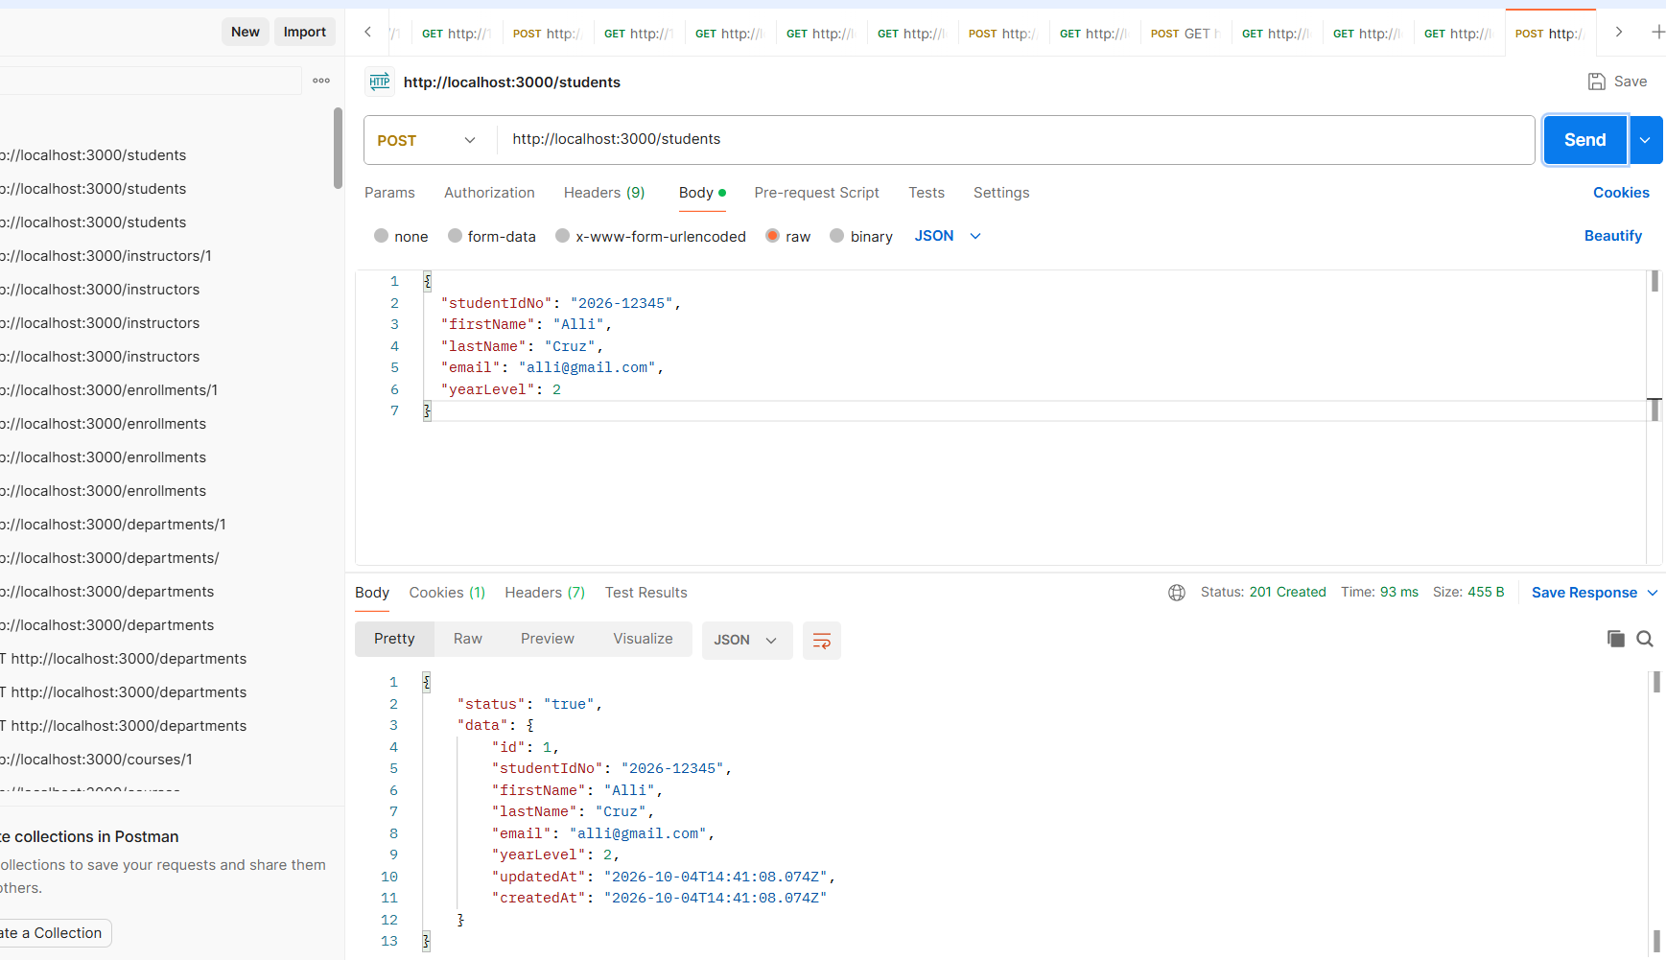
GET(ID) http://localhost:3000/students/1
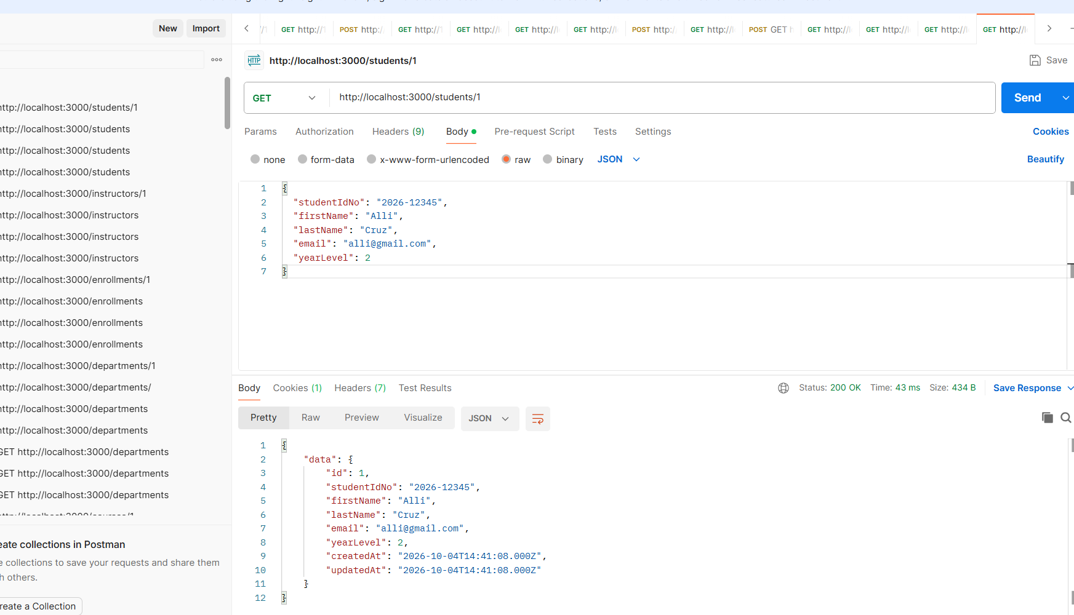

Routes
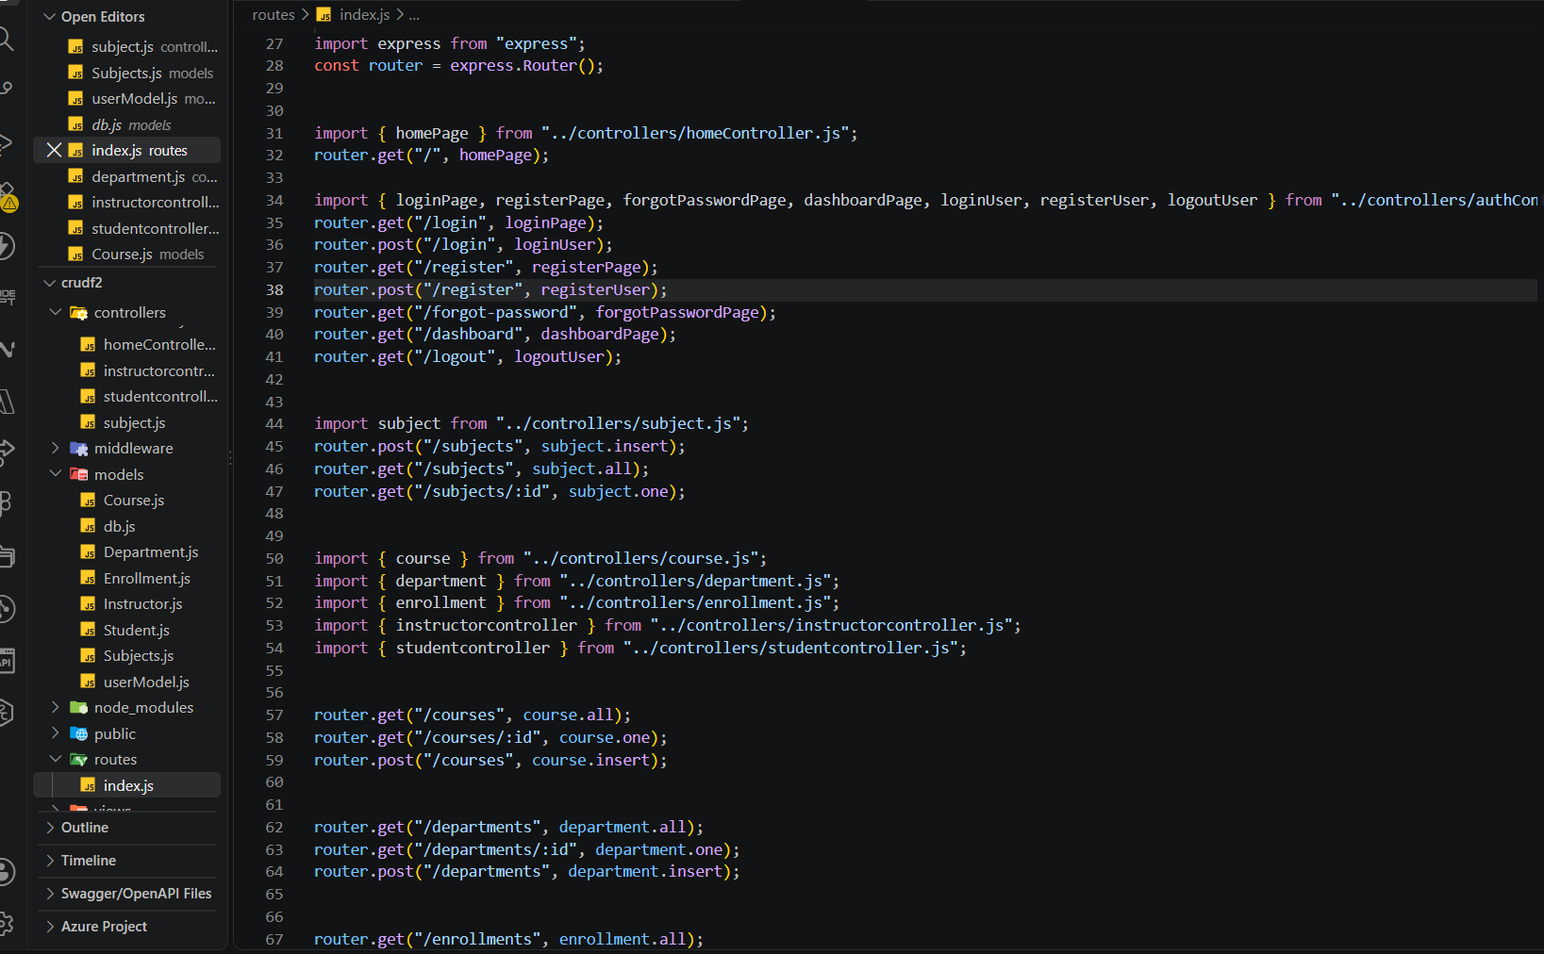
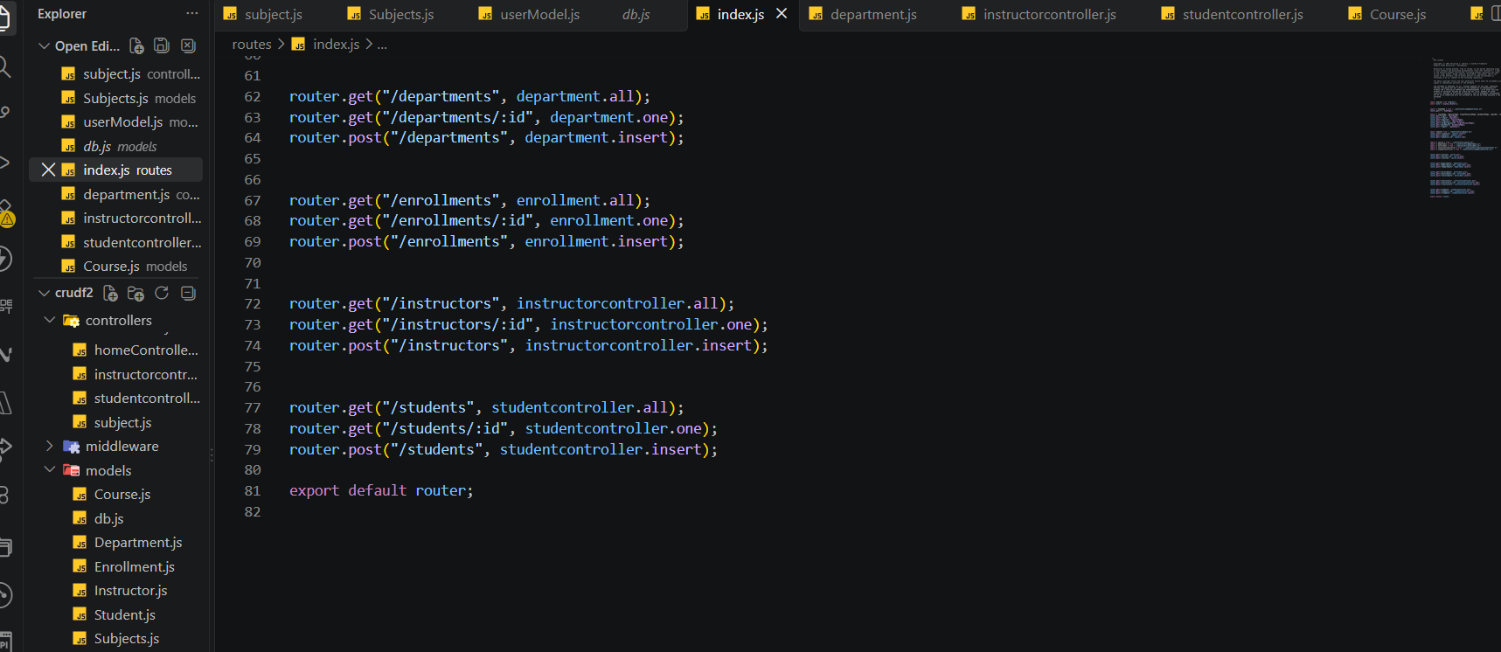

DATABASE
SUBJECT
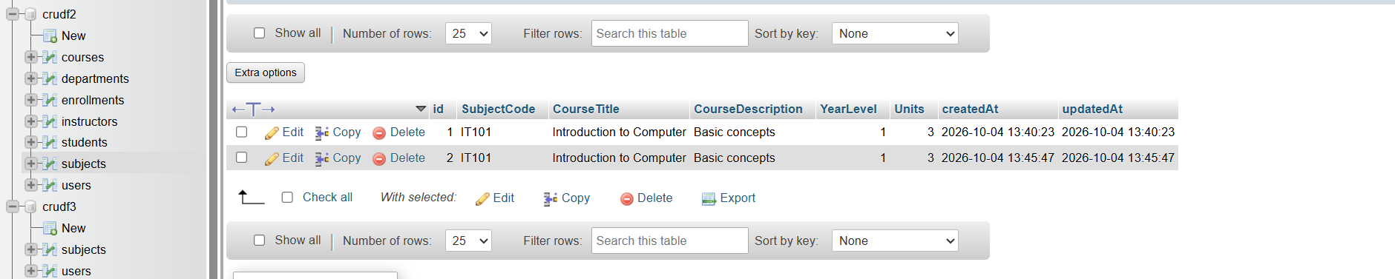
STUDENT
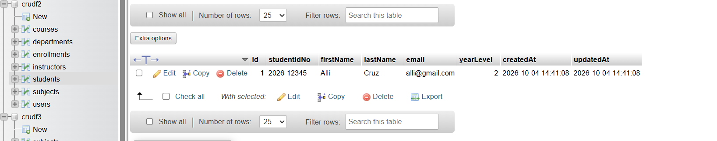
INSTRUCTORS
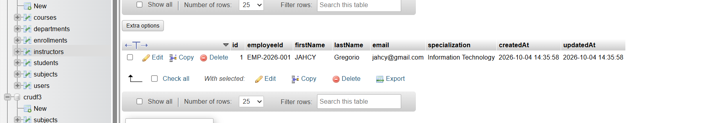
ENROLLMENTS
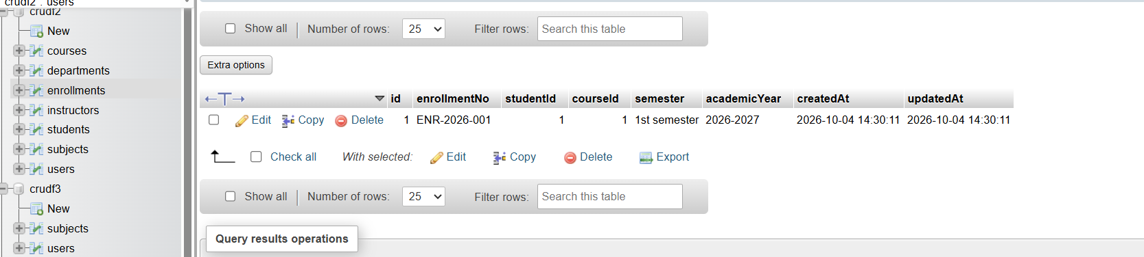

DEPARTMENTS
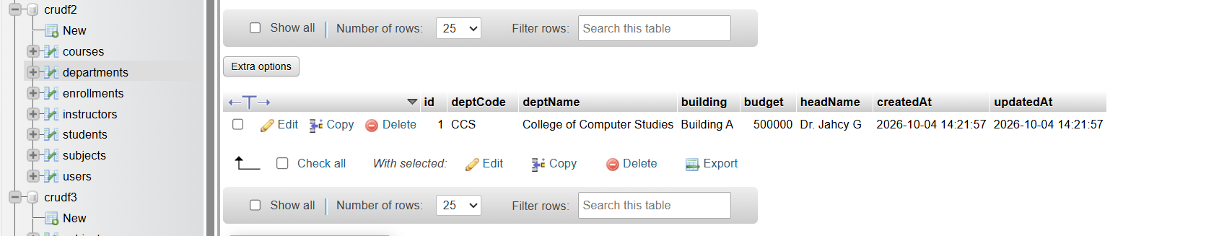
COURSES
